Storage Services
Cloud Storage
- Storage Classes
  - Standard
  - Nearline
  - Coldline
  - Archive
- Bucket Management
  - Versioning
  - Lifecycle Policies
  - Access Management
Persistent Disks
Filestore
Cloud Storage Security
- Encryption
- Bucket Policies
Networking in GCP
Virtual Private Cloud (VPC)
- VPC Architecture
- Subnets
- IP Addressing
Firewall Rules
Configuration
- Ingress Rules
- Egress Rules
Load Balancing
Types
- Global Load Balancer
- Internal Load Balancer
Database Services
Cloud SQL
Supported Databases
- MySQL
- PostgreSQL
- SQL Server
Firestore
NoSQL Database
- Collections
- Documents

Bigtable
Wide Column Database
- Use Cases
- Architecture
Memorystore
Caching Layer
- Redis
- Memcached

Storage Services
Storage is one of the fundamental components of cloud computing. Applications & organizations need reliable, durable, secure, scalable, & cost-effective solutions to store & manage their data.
GCP provides different storage services designed for different types of data, workloads, & application requirements.
GCP storage services support three major storage models:
- Object Storage
- Block Storage
- File Storage
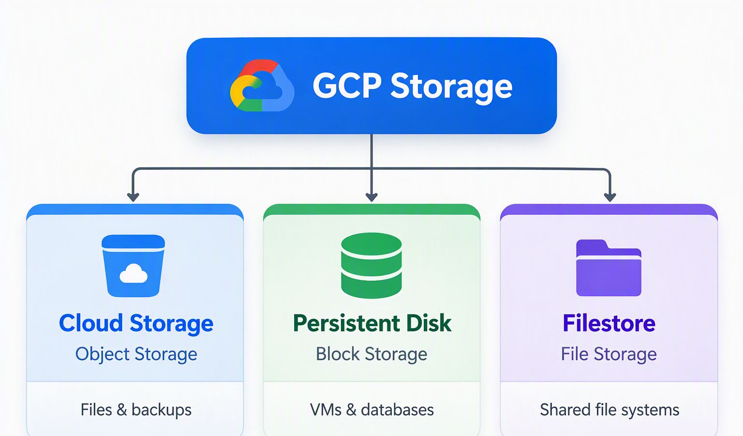
Google Cloud Storage
What is Cloud Storage?
It is a fully managed, scalable object storage service offered by GCP. It allows organizations to store & retrieve large amounts of unstructured data without managing physical storage infrastructure.
Cloud storage service is suitable for:
- Images & videos
- PDF documents & office files
- Applications backups
- Database backup files
- Log files
- Data analytics datasets
- Archived business records
- Static website assets
Key characteristics of Cloud Storage:
- Object-based storage
- High Scalability
- High durability
- Global accessibility
- Fully managed
- Usage-based pricing

Storage Classes
The purpose of storage classes is to help organizations optimize storage costs based on how frequently they expect to access their data.
- Standard – It is designed for frequently accessed data that requires immediate availability.
- Nearline – Its is designed for infrequently accessed data, typically accessed no more than once per month.
- Coldline – It is designed for the data accessed very infrequently, typically no more than once per quarter.
- Archive – It is designed for data that is rarely accessed & needs to be retained for long periods.

Storage Classes Comparison
Feature | Standard | Nearline | Coldline | Archive
Access frequency | Frequent | About monthly or less | About quarterly or less | About yearly or less
Minimum duration | None | 30 days | 90 days | 365 days
Storage cost | Highest | Lower | Very low | Lowest
Retrieval fee | No | Yes | Yes | Yes
Access latency | Low | Low | Low | Low
Primary use | Active data | Periodic backups | Long-term backups | Archival

Bucket Management
What is a bucket?
A bucket is logical container used to store objects in Google Cloud Storage.
Key Bucket properties
- Globally unique name
- Location
- Access controls
- Storage class
- Lifecycle rules
- Versioning
- Lifecycle Policies
- Access Management
Persistent Disks
Persistent Disk is a durable, network-attached block storage service used primarily with Google Compute Engine VMs. It provides storage for OSs, applications, & databases.

Key characteristics of persistent disks
- Block-level storage
- Persistent data
- Independent storage lifecycle
- Snapshots
- Resizing
- Replication
Types of Persistent Disks
Disk Type | Description | Suitable Workloads
Standard Persistent Disk (pd-standard) | HDD-based, cost-oriented storage | Sequential workloads, general-purpose storage
Balanced Persistent Disk (pd-balanced) | SSD-based balance of price and performance | General applications and boot disks
SSD Persistent Disk (pd-ssd) | SSD-based, higher-performance storage | Databases and I/O-intensive applications
Extreme Persistent Disk (pd-extreme) | Designed for high IOPS requirements | Demanding database workloads
Important Persistent Disk Concepts
- Boot Disk
- Data Disk
- Snapshot
- Disk Attachment
- Zonal Disk
Filestore
It is fully managed file storage service that provides shared network file systems for cloud applications
Key characteristics of Filestore
- Fully managed file storage
- NFS-based shared file access
- Supports shared directories & files.
- Designed for low-latency file workloads
- Integrates with compute engines & supported google Kubernetes engine environments
- Provides capacity & performance options through different service tiers
How Filestore works?
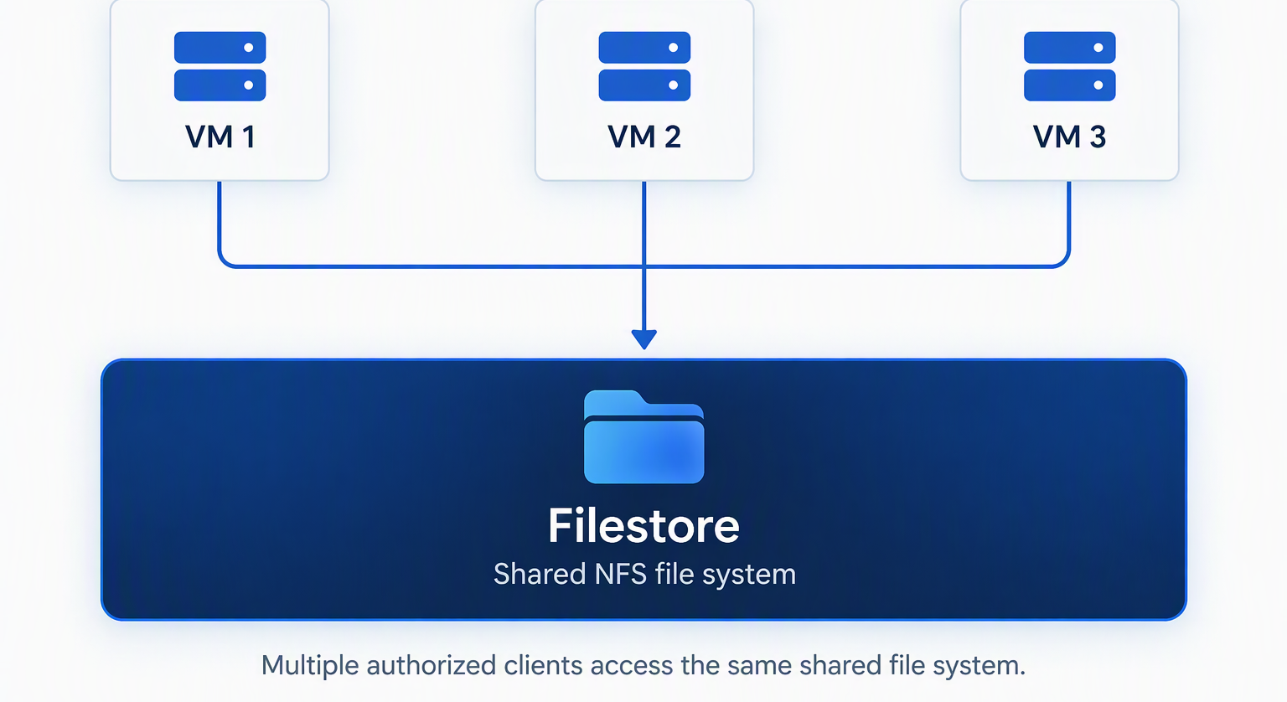
Filestore versus Persistent Disk
Feature | Filestore | Persistent Disk
Storage model | File | Block
Access protocol | NFS | Block device
Primary use | Shared file systems | VM operating systems and databases
Multi-client access | Core use case | Depends on disk type and supported attachment mode
Administration | Managed file server | Disk volume management
Common workload | Shared application files | VM boot and database volumes

Cloud Storage Security
- Encryption
- Bucket Policies
Database Services
GCP provides fully managed & scalable database services that allow organizations to store, organize, retrieve & manage data without having to maintain the underlying database infrastructure.
Major database services in GCP
Cloud SQL
Supported Databases
- MySQL
- PostgreSQL
- SQL Server

Cloud SQL Architecture
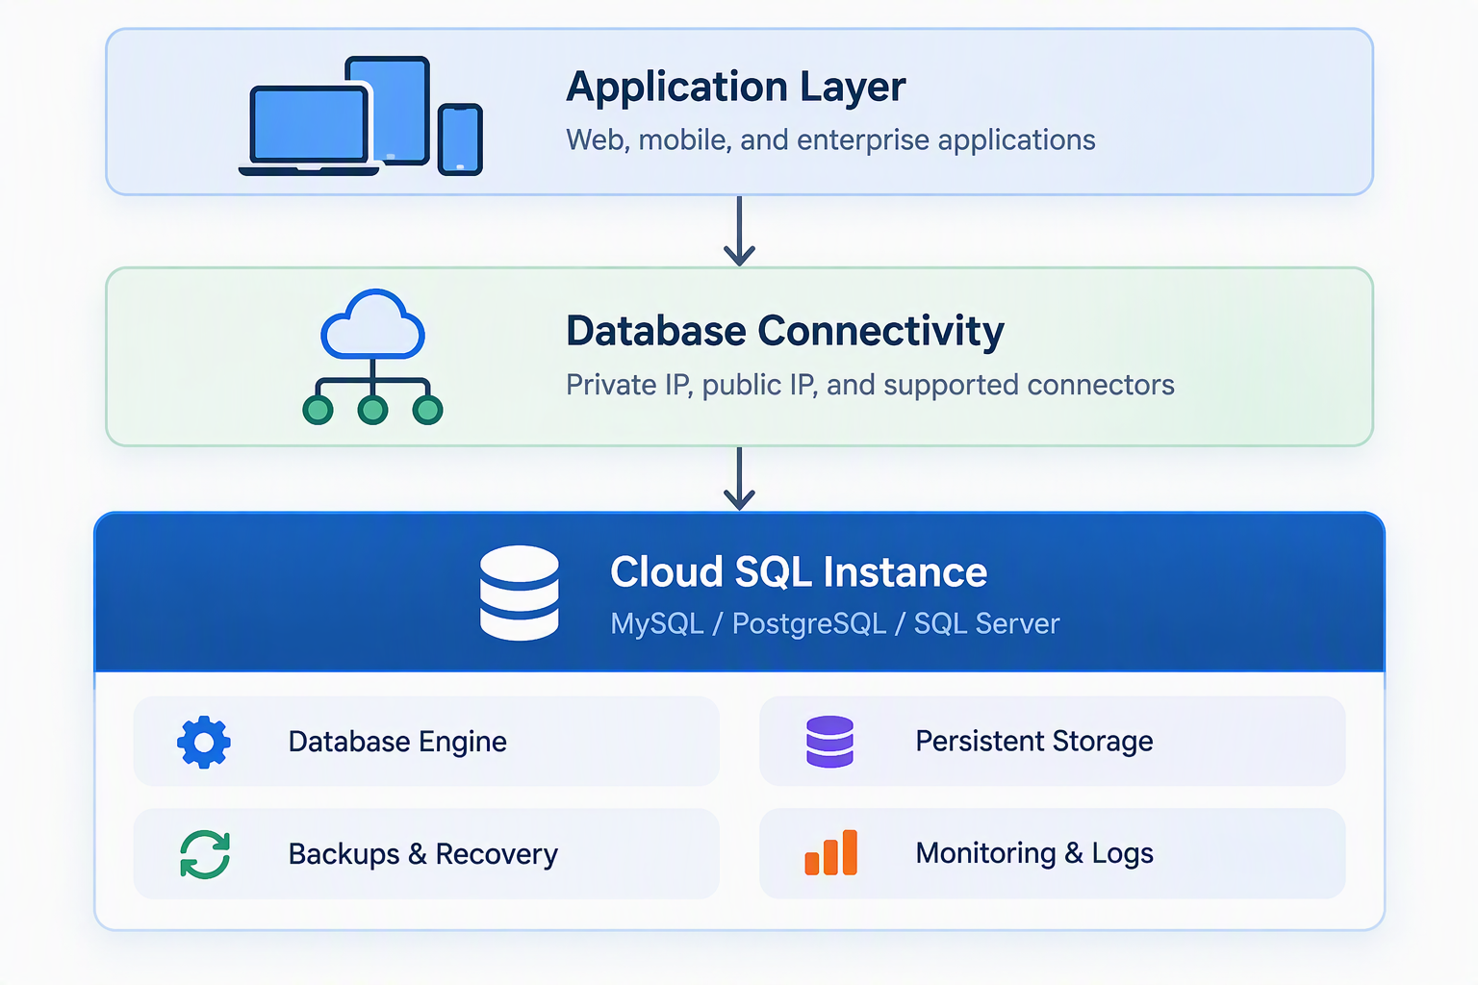
Firestore
It is a fully managed, serverless NoSQL document database provided by GCP.
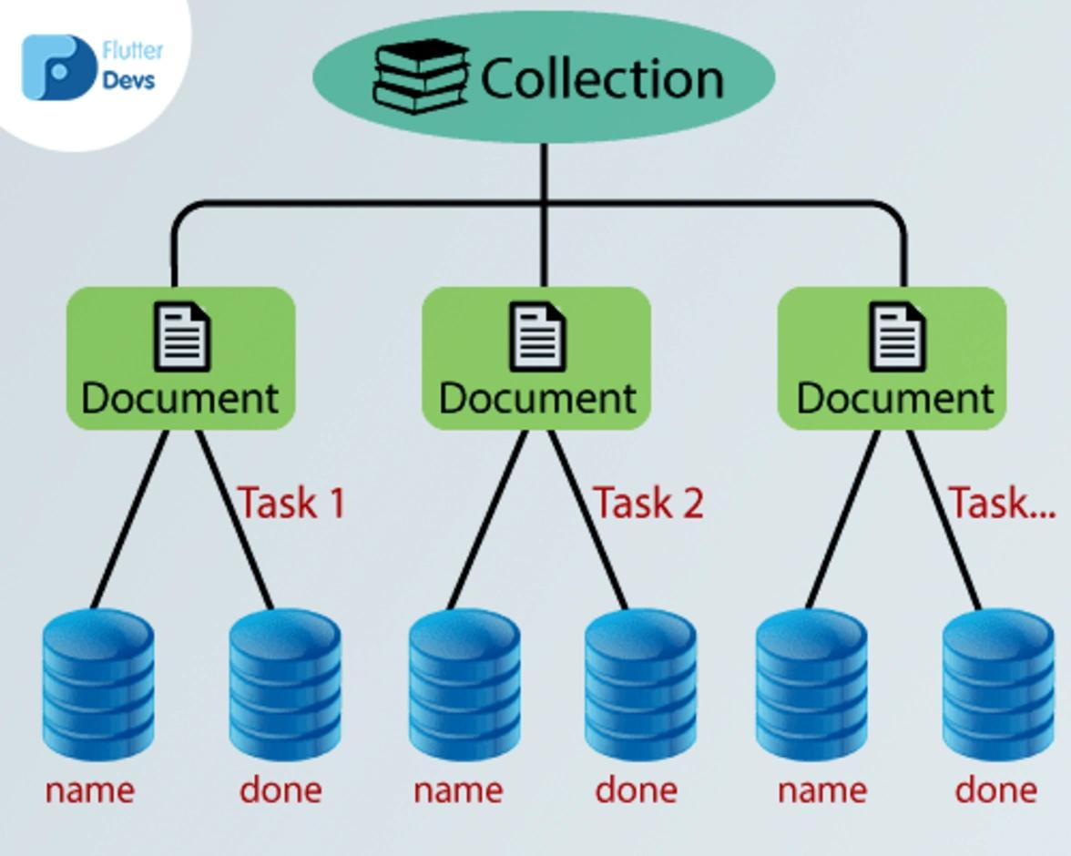
NoSQL Database
- Collections
- Documents
Bigtable
It is a fully managed, distributed, wide-column NoSQL database service designed to store & process very large volumes of data with high throughput & low latency.
Wide Column Database
- Use Cases
- Architecture
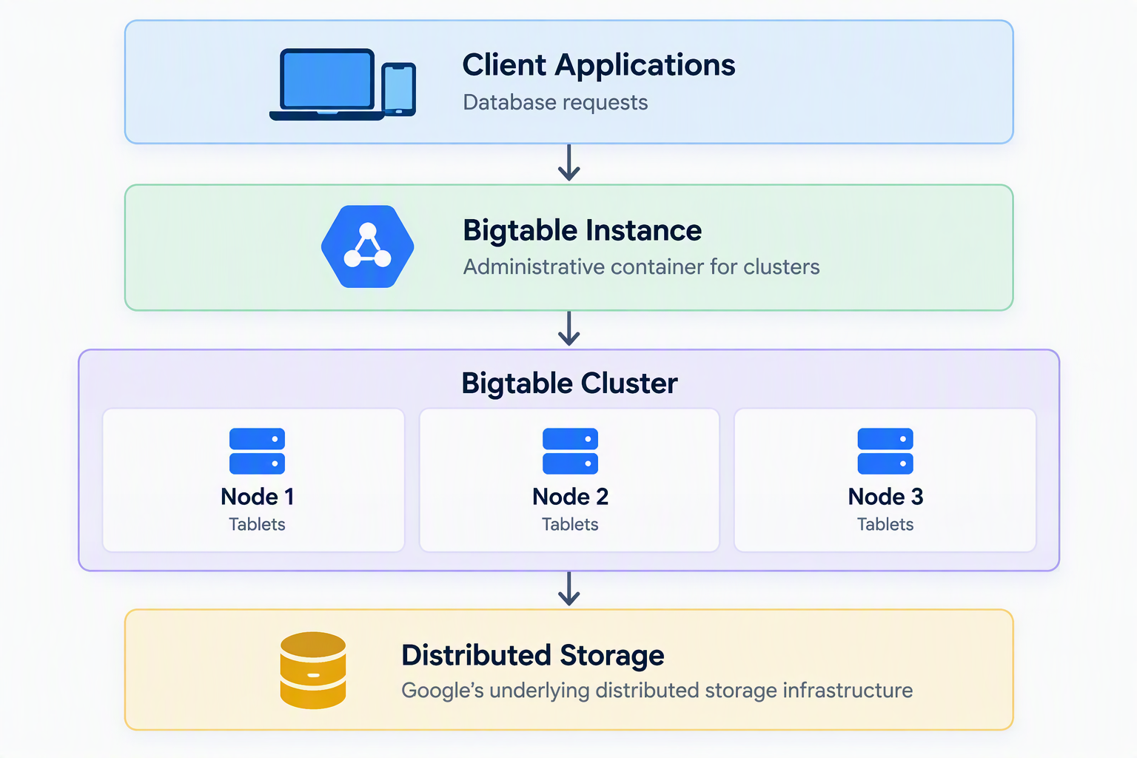
Memorystore
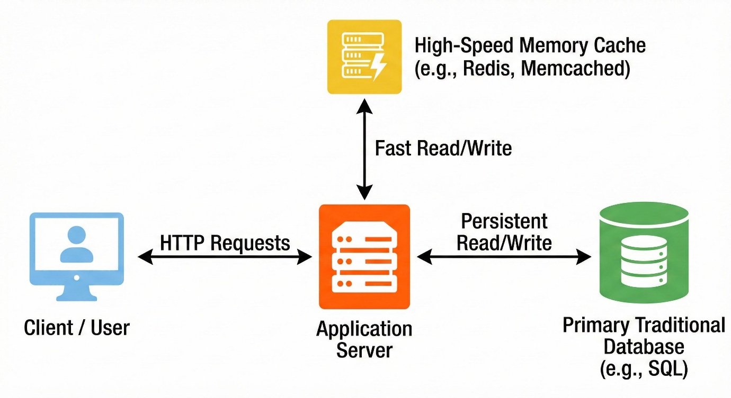
Caching Layer
- Redis
- Memcached

Redis vs MemCached
